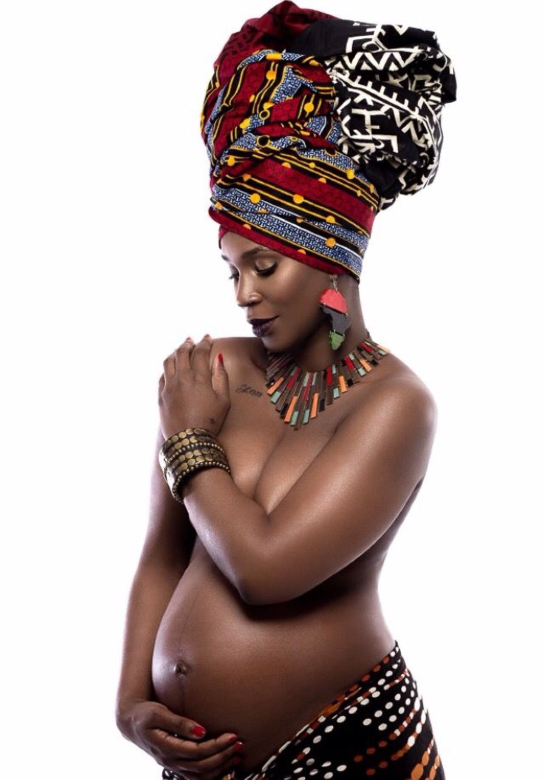

**Food**

**Gift bags**

**Arts and Craft Activities**

**Open Forum Discussion**

**And More**

**Wednesday, December 12th, 2018 1pm-4pm**

**Open Cities Health Center 409 Dunlap St N St Paul MN 55104**

***Nubian Moms***

**The Kick Off event**

